RunLinearScenario

* Takes in an array and loops through it in order
* Linear because the time to complete scales linearly with the size of input array
* As the arrays grew in magnitude (\*10 ), the times grew linearly.

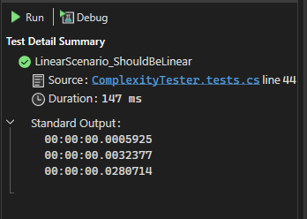

RunConstantScenario

* Takes an array and returns the element at 0
* The first test took significantly longer than both of the other tests. Even after warming up the method. This is likely the result of the way the compiler works with tests. Regardless, the test times were all with 1ms.
* As the array grew, the times remained constant within 1ms

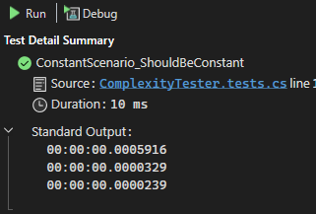

RunQuadraticScenario

* Takes an array and compares each element to itself and every other element in the array.
* As the arrays increase in magnitude (\*10) the time increases exponentially (\*100)
* As the array grew, the times remained constant within 1ms

